[DBMS Project Setup/Report](https://docs.google.com/document/d/1vZHS1Itaa6q_Mwz__7m4AYuAD8b7HzmwkAVQX_jgoCs/edit)  
This is just a rough draft. Enhancements needed. Actual data needs to be plugged for examples/testing.  
  
Regarding the setup: ***How to RUN with different docker files which create containers on maybe different networks.***

1. A docker file which initially runs the dml and ddl files.  
   NOTE: If the data is not being shown in the workbench. Use:

docker-compose down -v which will reset the mapped volumes.

1. Run Superset:

docker run --platform linux/amd64 -d -p 8088:8088 -e "SUPERSET_SECRET_KEY=admin@1234" --name my-superset apache/superset:2.1.2

1. docker exec -it my-superset superset fab create-admin

--username admin \

--firstname admin \

--lastname admin \

--email admin@gmail.com \

--password admin

1. Create a connection from Superset to the DB using host.docker.internal:3307

***How to RUN with a merged docker file (to be tested yet):***

docker-compose up -d

TODO: Write initialization script for superset to create admin user.

**VIEWS**

**Customer Overview**  
CREATE VIEW CustomerOverview AS

SELECT c.customer_id, COUNT(rs.service_id) AS total_rentals, AVG(rs.end_odo - rs.start_odo) AS average_distance

FROM dsr_customer c

JOIN dsr_rental_service rs ON c.customer_id = rs.customer_id

GROUP BY c.customer_id;

[**Customer Type Financial Summary**](http://localhost:8088/explore/?dashboard_page_id=pf0-TNAJ_s&slice_id=116)  
CREATE OR REPLACE VIEW FinancialOverview AS

SELECT c.customer_type,

COUNT(i.invoice_id) AS number_of_invoices,

SUM(i.invoice_amount) AS total_invoice_amount

FROM dsr_customer c

JOIN dsr_rental_service rs ON c.customer_id = rs.customer_id

JOIN dsr_invoice i ON rs.service_id = i.service_id

GROUP BY c.customer_type;

**Vehicle Class Performance**  
CREATE VIEW VehicleClassPerformance AS

SELECT vc.class_id, vc.class, COUNT(rs.service_id) AS total_rentals, SUM(i.invoice_amount) AS total_revenue

FROM dsr_vehicle_class vc

JOIN dsr_vehicle v ON vc.class_id = v.class_id

JOIN dsr_rental_service rs ON v.vehicle_id = rs.vehicle_id

JOIN dsr_invoice i ON rs.service_id = i.service_id

GROUP BY vc.class_id;

Business analysis with 6 SQLs using your project data:  
  
Query results are based on the current state of the database. Should be changed before submitting.

**Answer.1)**

*PURPOSE:*

By joining *dsr_customer, dsr_rental_service, dsr_vehicle, dsr_invoice, dsr_vehicle_class* tables, the query calculates the total number of rentals and the total revenue generated, grouped by the type of customer (individual or corporate) and the class of vehicle rented.

*QUERY:*

SELECT c.customer_type, vc.class, COUNT(rs.service_id) AS rentals, SUM(i.invoice_amount) AS revenue

FROM dsr_customer c

JOIN dsr_rental_service rs ON c.customer_id = rs.customer_id

JOIN dsr_vehicle v ON rs.vehicle_id = v.vehicle_id

JOIN dsr_vehicle_class vc ON v.class_id = vc.class_id

JOIN dsr_invoice i ON rs.service_id = i.service_id

GROUP BY c.customer_type, vc.class;

*QUERY RESULT:*

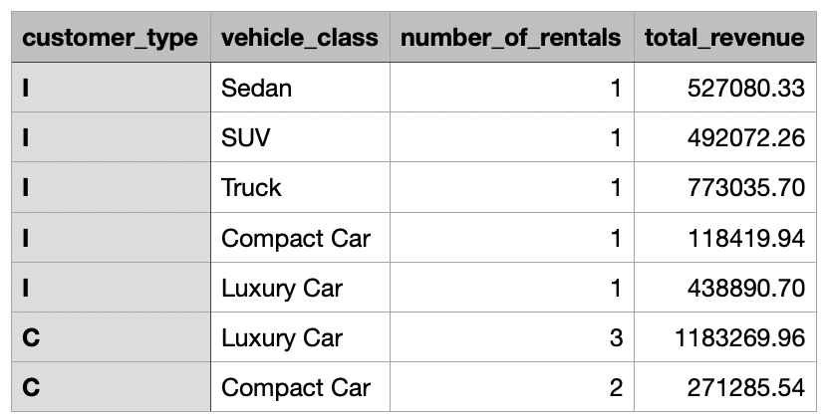

**Answer.2)**

*PURPOSE:*

Serves the business purpose of recognizing high-value customers for potential rewards or loyalty programs. By acknowledging and incentivizing these top spenders, the company can encourage continued patronage and potentially increase customer lifetime value. This data can also contribute to marketing strategies targeted at customer retention and engagement.

*QUERY:*

SELECT c.customer_id, c.first_name, c.last_name, SUM(i.invoice_amount) AS total_spent

FROM dsr_customer c

JOIN dsr_rental_service rs ON c.customer_id = rs.customer_id

JOIN dsr_invoice i ON rs.service_id = i.service_id

GROUP BY c.customer_id

HAVING total_spent > (

SELECT AVG(total_spent) FROM (

SELECT SUM(i.invoice_amount) AS total_spent

FROM dsr_rental_service rs

JOIN dsr_invoice i ON rs.service_id = i.service_id

GROUP BY rs.customer_id

) AS subquery

);

*QUERY RESULT:*

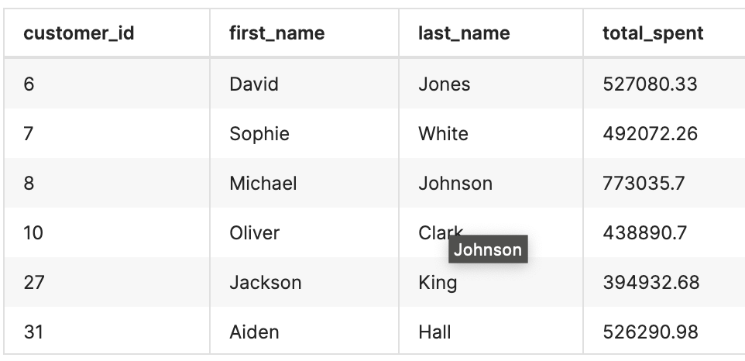

**Answer.3)**

*PURPOSE:*

This query helps identify customers with above-average rental durations, providing critical insights for customer segmentation and personalized marketing strategies. It aids in effective resource allocation and fleet management, ensuring availability for long-term bookings. Additionally, this data is instrumental for revenue forecasting and making strategic business decisions, such as tailoring services and adjusting pricing models to meet the needs of frequent long-term renters.

*QUERY:*

SELECT

c.customer_id,

c.first_name,

c.last_name,

(SELECT AVG(DATEDIFF(rs.dropoff_date, rs.pickup_date))

FROM dsr_rental_service rs

WHERE rs.customer_id = c.customer_id AND rs.dropoff_date IS NOT NULL) AS avg_rental_duration

FROM

dsr_customer c

HAVING

avg_rental_duration > (SELECT AVG(DATEDIFF(rs.dropoff_date, rs.pickup_date))

FROM dsr_rental_service rs

WHERE rs.dropoff_date IS NOT NULL)

ORDER BY

avg_rental_duration DESC;

*QUERY RESULT:*

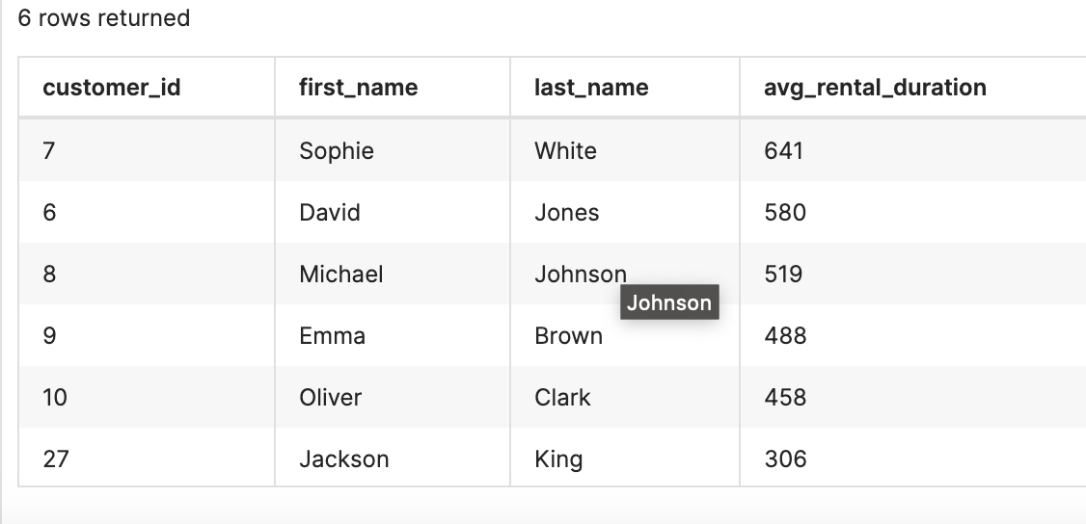

**Answer.4)**

*PURPOSE:*

*QUERY:*

*QUERY RESULT:*

**Answer.5)**

*PURPOSE:*

By aggregating the invoice amounts for each vehicle class, the query calculates the total revenue contributed by each class. This information can be extremely valuable for business decisions, such as identifying which vehicle classes are most profitable, planning vehicle purchases, or tailoring marketing strategies to promote certain types of vehicles. It essentially helps in understanding the performance of different segments of the rental fleet in terms of revenue generation.

*QUERY:*

WITH RentalRev AS (

SELECT vc.class, SUM(i.invoice_amount) AS rev

FROM dsr_rental_service rs

JOIN dsr_vehicle v ON rs.vehicle_id = v.vehicle_id

JOIN dsr_vehicle_class vc ON v.class_id = vc.class_id

JOIN dsr_invoice i ON rs.service_id = i.service_id

WHERE rs.dropoff_date BETWEEN '2023-01-01' AND '2023-12-31'

GROUP BY vc.class

)

SELECT class, rev FROM RentalRev;

*QUERY RESULT:*

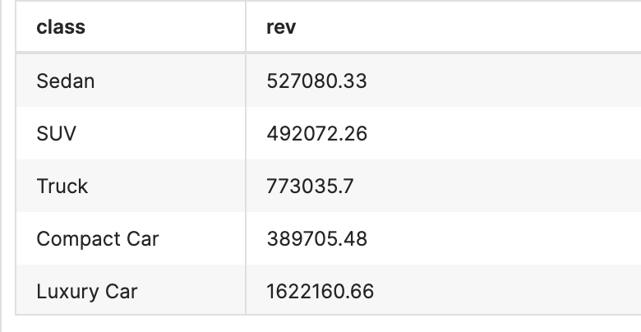

**Answer.6)**

*PURPOSE:*

This query identifies the top five corporate clients for a car rental service based on the total number of rentals. By pinpointing the most active corporate customers, the car rental company can tailor specific marketing strategies, loyalty programs, or exclusive offers to these high-value clients. This focused approach helps in strengthening business relationships, increasing customer retention, and potentially driving more revenue from corporate accounts. The data gathered can also guide decisions on resource allocation, such as fleet management and customer service enhancements targeted at these key corporate partners.

*QUERY:*

SELECT c.corp_id, corp.corp_name, COUNT(rs.service_id) AS total_rentals

FROM dsr_rental_service rs

JOIN dsr_customer cust ON rs.customer_id = cust.customer_id

JOIN dsr_cust_corporate c ON cust.customer_id = c.customer_id

JOIN dsr_corporation corp ON c.corp_id = corp.corp_id

WHERE cust.customer_type = 'C'

GROUP BY c.corp_id, corp.corp_name

ORDER BY total_rentals DESC

LIMIT 5;

*QUERY RESULT:*

